LoginForm.cs

namespace _101062225_eventManagement_project

{

public partial class LoginForm : Form

{

public LoginForm()

{

InitializeComponent();

}

private void btnLogin_Click(object sender, EventArgs e){

String Username = "admin";

String Password = "admin";

if(txtUser.Text == Username && txtPassword.Text == Password)

{

MessageBox.Show("Login Successful", "Login", MessageBoxButtons.OK, MessageBoxIcon.Asterisk);

this.Hide();

Main_Form f2 = new Main_Form();

f2.ShowDialog(); //

}

else

{

MessageBox.Show("Please Check your Username and Password", "Login", MessageBoxButtons.OK, MessageBoxIcon.Error);

}

}

private void TxtUser_Validating(object sender, CancelEventArgs e)

{

if (string.IsNullOrWhiteSpace(txtUser.Text))

{

e.Cancel = true;

txtUser.Focus();

errorProviderApp.SetError(txtUser, "Name should not be left blank!");

}

else

{

e.Cancel = false;

errorProviderApp.SetError(txtUser, "");

}

}

private void TxtPassword_Validating(object sender, CancelEventArgs e)

{

if (string.IsNullOrWhiteSpace(txtPassword.Text))

{

e.Cancel = true;

txtPassword.Focus();

errorProviderApp.SetError(txtPassword, "Name should not be left blank!");

}

else

{

e.Cancel = false;

errorProviderApp.SetError(txtPassword, "");

}

} }}

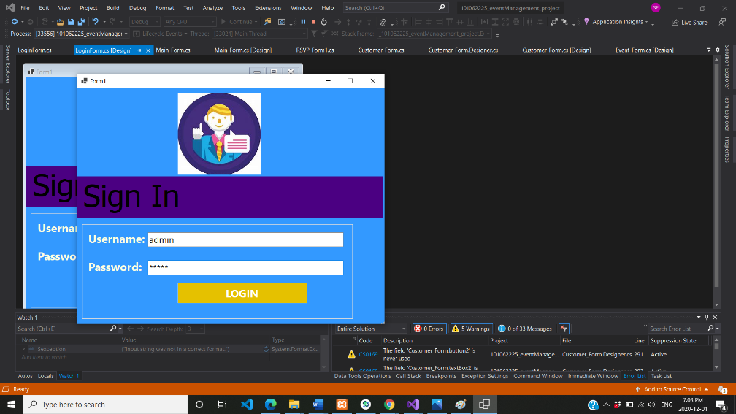

Main_Form.cs

namespace _101062225_eventManagement_project

{

public partial class Main_Form : Form

{

public Main_Form()

{

InitializeComponent();

}

private void Main_Form_FormClosing(object sender, FormClosingEventArgs e)

{

Application.Exit();

}

private void button1_Click(object sender, EventArgs e)

{

this.Hide();

Customer_Form f = new Customer_Form();

f.ShowDialog();

}

private void btnLog_Click(object sender, EventArgs e)

{

this.Hide();

LoginForm f1 = new LoginForm();

f1.ShowDialog();

}

private void btnEventPage_Click(object sender, EventArgs e)

{

this.Hide();

Event_Form f2 = new Event_Form();

f2.ShowDialog();

}

private void btnRSVPpage_Click(object sender, EventArgs e)

{

this.Hide();

RSVP_Form1 f3 = new RSVP_Form1();

f3.ShowDialog();

}}}

Customer_Form.cs

using System.Windows.Forms;

using System.Data.SqlClient;

namespace _101062225_eventManagement_project

{

public partial class Customer_Form : Form

{

SqlConnection sqlCon = new SqlConnection(@"Data Source=(LocalDB)\MSSQLLocalDB;AttachDbFilename=C:\Users\reyaf\source\repos\101062225_eventManagement_project\DB\ContactDB.mdf;Integrated Security=True;Connect Timeout=30");

int CustomerId = 0;

public Customer_Form()

{

InitializeComponent();

}

private void btnSave_Click_1(object sender, EventArgs e)

{

try

{

if (sqlCon.State == ConnectionState.Closed)

sqlCon.Open();

if (btnSave.Text == "Save")

{

SqlCommand sqlCmd = new SqlCommand("ContactAddorEdit", sqlCon);

sqlCmd.CommandType = CommandType.StoredProcedure;

sqlCmd.Parameters.AddWithValue("@mode", "Add");

sqlCmd.Parameters.AddWithValue("@CustomerId", 0);

sqlCmd.Parameters.AddWithValue("@FirstName", txtFname.Text.Trim());

sqlCmd.Parameters.AddWithValue("@LastName", txtLname.Text.Trim());

sqlCmd.Parameters.AddWithValue("@PhoneNumber", txtPhone.Text.Trim());

sqlCmd.Parameters.AddWithValue("@BookingId", txtBooking.Text.Trim());

sqlCmd.ExecuteNonQuery();

MessageBox.Show("Saved Successfully");

}

else

{

SqlCommand sqlCmd = new SqlCommand("ContactAddorEdit", sqlCon);

sqlCmd.CommandType = CommandType.StoredProcedure;

sqlCmd.Parameters.AddWithValue("@mode", "Edit");

sqlCmd.Parameters.AddWithValue("@CustomerId", CustomerId);

sqlCmd.Parameters.AddWithValue("@FirstName", txtFname.Text.Trim());

sqlCmd.Parameters.AddWithValue("@LastName", txtLname.Text.Trim());

sqlCmd.Parameters.AddWithValue("@PhoneNumber", txtPhone.Text.Trim());

sqlCmd.Parameters.AddWithValue("@BookingId", txtBooking.Text.Trim());

sqlCmd.ExecuteNonQuery();

MessageBox.Show("Updated Successfully");

}

}

catch (Exception ex)

{

MessageBox.Show(ex.Message, "Error Message");

}

finally

{

sqlCon.Close();

}

}

void FillDataGridView()

{

if (sqlCon.State == ConnectionState.Closed)

sqlCon.Open();

SqlDataAdapter sqlDa = new SqlDataAdapter("ContactViewOrSearch", sqlCon);

sqlDa.SelectCommand.CommandType = CommandType.StoredProcedure;

sqlDa.SelectCommand.Parameters.AddWithValue("@ContactName", txtSearch.Text.Trim());

DataTable dtbl = new DataTable();

sqlDa.Fill(dtbl);

dgvContacts.DataSource = dtbl;

sqlCon.Close();

}

private void btnReset_Click_1(object sender, EventArgs e)

{

Reset();

}

private void btnSearch_Click(object sender, EventArgs e)

{

try

{

FillDataGridView();

}

catch (Exception ex)

{

MessageBox.Show(ex.Message, "Invalid Entry");

}

}

private void dgvContacts_DoubleClick(object sender, EventArgs e)

{

if (dgvContacts.CurrentRow.Index != -1)

{

CustomerId = Convert.ToInt32(dgvContacts.CurrentRow.Cells[0].Value.ToString());

txtFname.Text = dgvContacts.CurrentRow.Cells[1].Value.ToString();

txtLname.Text = dgvContacts.CurrentRow.Cells[2].Value.ToString();

txtPhone.Text = dgvContacts.CurrentRow.Cells[3].Value.ToString();

txtBooking.Text = dgvContacts.CurrentRow.Cells[4].Value.ToString();

btnSave.Text = "Update";

btnDelete.Enabled = true;

}

}

void Reset()

{

txtFname.Text = txtLname.Text = txtPhone.Text = txtBooking.Text = "";

btnSave.Text = "Save";

CustomerId = 0;

btnDelete.Enabled = false;

}

private void Customer_Form_Load(object sender, EventArgs e)

{

Reset();

FillDataGridView();

}

private void btnDelete_Click_1(object sender, EventArgs e)

{

try

{

if (sqlCon.State == ConnectionState.Closed)

sqlCon.Open();

SqlCommand sqlCmd = new SqlCommand("ContactDeletion", sqlCon);

sqlCmd.CommandType = CommandType.StoredProcedure;

sqlCmd.Parameters.AddWithValue("@CustomerId", CustomerId);

sqlCmd.ExecuteNonQuery();

MessageBox.Show("Deleted Successfully");

Reset();

FillDataGridView();

}

catch (Exception ex)

{

MessageBox.Show(ex.Message, "ERROR MESSAGE");

}

}

private void btnNext_Click(object sender, EventArgs e)

{

this.Hide();

Event_Form f1 = new Event_Form();

f1.ShowDialog();

}

private void btnBack_Click(object sender, EventArgs e)

{

this.Hide();

Main_Form f2 = new Main_Form();

f2.ShowDialog();

}

private void txtFname_Validating(object sender, CancelEventArgs e)

{

if (string.IsNullOrWhiteSpace(txtFname.Text))

{

e.Cancel = true;

txtFname.Focus();

errorProviderApp.SetError(txtFname, "Name should not be left blank!");

}

else

{

e.Cancel = false;

errorProviderApp.SetError(txtFname, "");

}

}

private void txtLname_Validating(object sender, CancelEventArgs e)

{

if (string.IsNullOrWhiteSpace(txtLname.Text))

{

e.Cancel = true;

txtFname.Focus();

errorProviderApp.SetError(txtLname, "Name should not be left blank!");

}

else

{

e.Cancel = false;

errorProviderApp.SetError(txtLname, "");

}

}

private void TxtPhone_Validating(object sender, CancelEventArgs e)

{

if (string.IsNullOrWhiteSpace(txtPhone.Text))

{

e.Cancel = true;

txtPhone.Focus();

errorProviderApp.SetError(txtPhone, " should not be left blank!");

}

else

{

e.Cancel = false;

errorProviderApp.SetError(txtPhone, "");

}

}

private void TxtBooking_Validating(object sender, EventArgs e)

{

if (string.IsNullOrWhiteSpace(txtBooking.Text))

{

txtBooking.Focus();

errorProviderApp.SetError(txtBooking, "Booking should not be left blank!");

}

else

{

errorProviderApp.SetError(txtBooking, "");

}

}

}

}

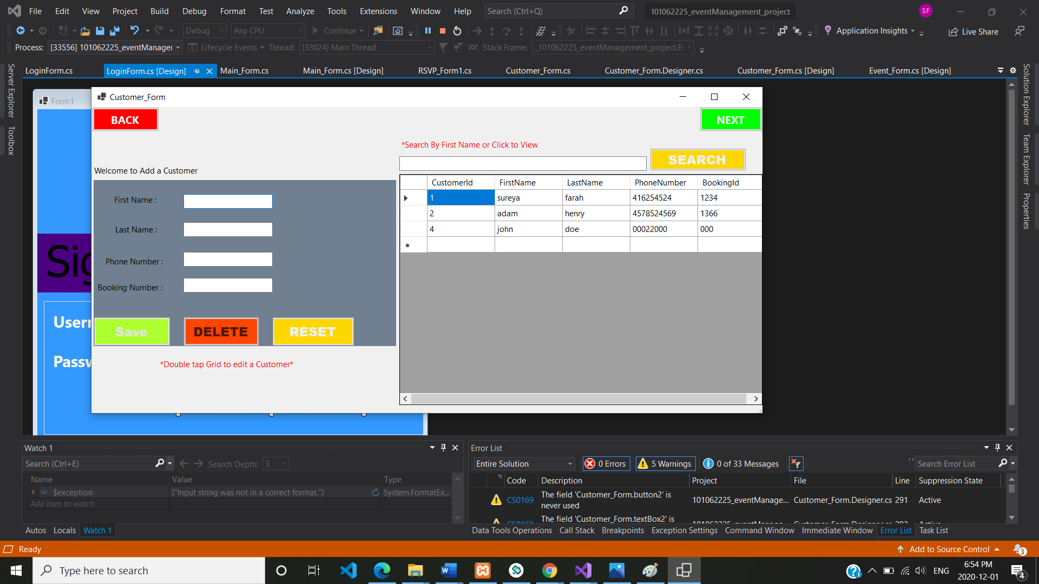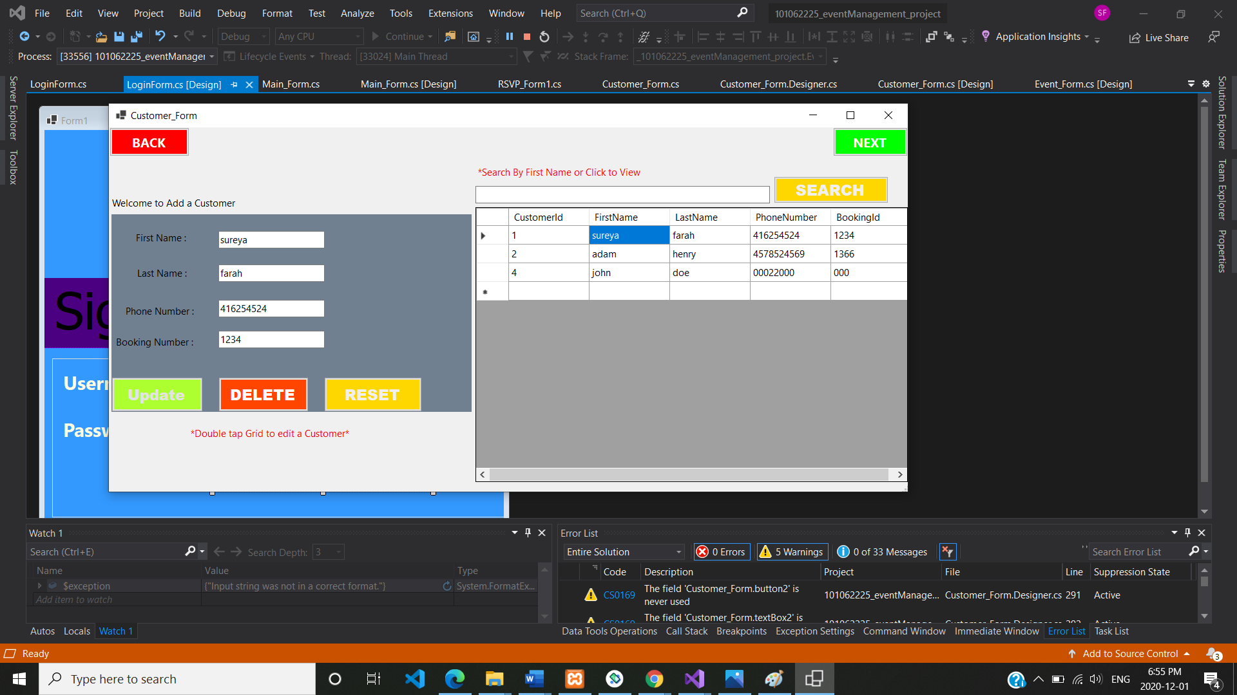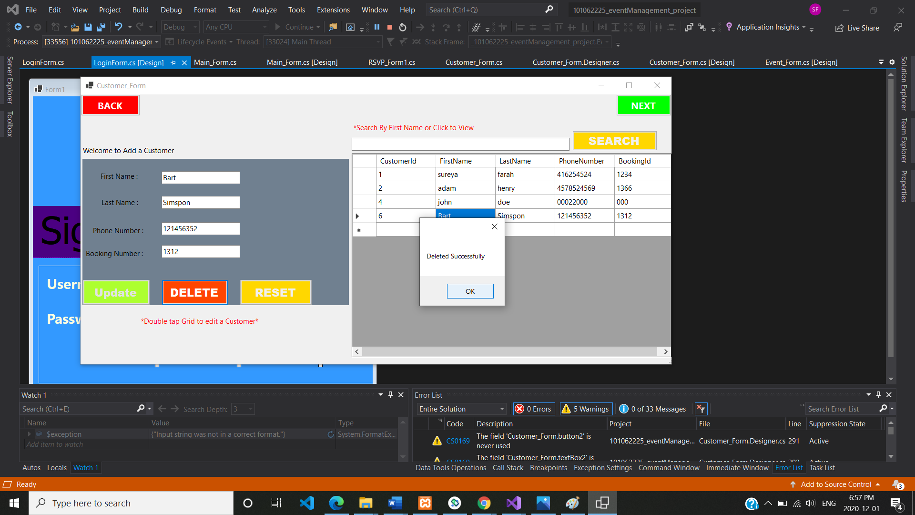

Event_Form.cs

namespace _101062225_eventManagement_project

{

public partial class Event_Form : Form

{

SqlConnection sqlCon = new SqlConnection(@"Data Source=(LocalDB)\MSSQLLocalDB;AttachDbFilename=C:\Users\reyaf\source\repos\101062225_eventManagement_project\DB\ContactDB.mdf;Integrated Security=True;Connect Timeout=30");

int EventId = 0;

public Event_Form()

{

InitializeComponent();

}

private void BtnBack_Click(object sender, EventArgs e)

{

this.Hide();

Customer_Form f1 = new Customer_Form();

f1.ShowDialog();

}

private void BtnNext_Click(object sender, EventArgs e)

{

this.Hide();

RSVP_Form1 f2 = new RSVP_Form1();

f2.ShowDialog();

}

private void Event_Form_Load(object sender, EventArgs e)

{

EventReset();

FillSearchDataGridView();

// FillEventDataGridView();

}

private void DgvEvents_DoubleClick(object sender, EventArgs e)

{

if (dgvEvents.CurrentRow.Index != -1)

{

EventId = Convert.ToInt32(dgvEvents.CurrentRow.Cells[0].Value.ToString());

txtEventName.Text = dgvEvents.CurrentRow.Cells[1].Value.ToString();

txtEventDate.Text = dgvEvents.CurrentRow.Cells[2].Value.ToString();

txtPeople.Text = dgvEvents.CurrentRow.Cells[3].Value.ToString();

txtVenue.Text = dgvEvents.CurrentRow.Cells[4].Value.ToString();

btnEventSave.Text = "Update";

btnEventDelete.Enabled = true;

}

}

/* void FillEventDataGridView()

{

if (sqlCon.State == ConnectionState.Closed)

sqlCon.Open();

SqlDataAdapter sqlDa = new SqlDataAdapter("EventByNameViewOrSearch", sqlCon);

sqlDa.SelectCommand.CommandType = CommandType.StoredProcedure;

sqlDa.SelectCommand.Parameters.AddWithValue("@EventName", txtEventSearch.Text.Trim());

DataTable dtbl = new DataTable();

sqlDa.Fill(dtbl);

dgvEvents.DataSource = dtbl;

sqlCon.Close();

}*/

void FillSearchDataGridView()

{

if (sqlCon.State == ConnectionState.Closed)

sqlCon.Open();

SqlDataAdapter sqlDa = new SqlDataAdapter("EventByNameViewOrSearch", sqlCon);

sqlDa.SelectCommand.CommandType = CommandType.StoredProcedure;

sqlDa.SelectCommand.Parameters.AddWithValue("@EventName", txtEventSearch.Text.Trim());

DataTable dtbl = new DataTable();

sqlDa.Fill(dtbl);

dgvEvents.DataSource = dtbl;

sqlCon.Close();

}

void EventReset()

{

txtEventName.Text = txtEventDate.Text = txtPeople.Text = txtVenue.Text= "";

btnEventSave.Text = "Save";

EventId = 0;

btnEventDelete.Enabled = false;

}

private void BtnEventSearch_Click(object sender, EventArgs e)

{

try

{

FillSearchDataGridView();

}

catch (Exception ex)

{

MessageBox.Show(ex.Message, "Invalid Entry");

}

}

private void BtnEventDelete_Click_1(object sender, EventArgs e)

{

try

{

if (sqlCon.State == ConnectionState.Closed)

sqlCon.Open();

SqlCommand sqlCmd = new SqlCommand("EventDeletion", sqlCon);

sqlCmd.CommandType = CommandType.StoredProcedure;

sqlCmd.Parameters.AddWithValue("@EventId", EventId);

sqlCmd.ExecuteNonQuery();

MessageBox.Show("Deleted Successfully");

EventReset();

FillSearchDataGridView();

}

catch (Exception ex)

{

MessageBox.Show(ex.Message, "ERROR MESSAGE");

}

}

private void BtnEventSave_Click(object sender, EventArgs e)

{

try

{

if (sqlCon.State == ConnectionState.Closed)

sqlCon.Open();

if (btnEventSave.Text == "Save")

{

SqlCommand sqlCmd = new SqlCommand("EventAddorEdit", sqlCon);

sqlCmd.CommandType = CommandType.StoredProcedure;

sqlCmd.Parameters.AddWithValue("@mode", "Add");

sqlCmd.Parameters.AddWithValue("@EventId", 0);

sqlCmd.Parameters.AddWithValue("@EventName", txtEventName.Text.Trim());

sqlCmd.Parameters.AddWithValue("@EventDate", txtEventDate.Text.Trim());

sqlCmd.Parameters.AddWithValue("@PeopleAttending", txtPeople.Text.Trim());

sqlCmd.Parameters.AddWithValue("@EventVenue", txtVenue.Text.Trim());

sqlCmd.ExecuteNonQuery();

MessageBox.Show("Saved Successfully");

}

else

{

SqlCommand sqlCmd = new SqlCommand("EventAddorEdit", sqlCon);

sqlCmd.CommandType = CommandType.StoredProcedure;

sqlCmd.Parameters.AddWithValue("@mode", "Edit");

sqlCmd.Parameters.AddWithValue("@EventId", EventId);

sqlCmd.Parameters.AddWithValue("@EventName", txtEventName.Text.Trim());

sqlCmd.Parameters.AddWithValue("@EventDate", txtEventDate.Text.Trim());

sqlCmd.Parameters.AddWithValue("@PeopleAttending", txtPeople.Text.Trim());

sqlCmd.Parameters.AddWithValue("@EventVenue", txtVenue.Text.Trim());

sqlCmd.ExecuteNonQuery();

MessageBox.Show("Updated Successfully");

}

}

catch (Exception ex)

{

MessageBox.Show(ex.Message, "Error Message");

}

finally

{

sqlCon.Close();

}

}

private void BtnEventReset_Click(object sender, EventArgs e)

{

EventReset();

FillSearchDataGridView();

}

private void txtEventName_Validatin(object sender, CancelEventArgs e)

{

if (string.IsNullOrWhiteSpace(txtEventName.Text)) {

e.Cancel = true;

txtEventName.Focus();

errorProvider1.SetError(txtEventName, "Name should not be left blank!");

}

else

{

e.Cancel = false;

errorProvider1.SetError(txtEventName, "");

}

}

private void TxtVenue_Validating(object sender, CancelEventArgs e)

{

if (string.IsNullOrWhiteSpace(txtVenue.Text))

{

e.Cancel = true;

txtEventDate.Focus();

errorProvider1.SetError(txtVenue, "Name should not be left blank!");

}

else

{

e.Cancel = false;

errorProvider1.SetError(txtVenue, "");

}

}

private void TxtPeople_KeyPress(object sender, KeyPressEventArgs e)

{

char ch = e.KeyChar;

if (!Char.IsDigit(ch) && ch != 8)

{

e.Handled = true;

}

}

private void TxtDate_Validating(object sender, CancelEventArgs e)

{

Regex reg = new Regex(@"^(\d{1,2})/(\d{1,2})/(\d{4})$");

Match m = reg.Match(txtEventDate.Text);

if (m.Success)

{

int dd = int.Parse(m.Groups[1].Value);

int mm = int.Parse(m.Groups[2].Value);

int yyyy = int.Parse(m.Groups[3].Value);

e.Cancel = dd < 1 || dd > 31 || mm < 1 || mm > 12 || yyyy > 2020;

}

else e.Cancel = true;

if (e.Cancel)

{

if (MessageBox.Show("Wrong date format. The correct format is dd/mm/yyyy\n+ dd should be between 1 and 31.\n+ mm should be between 1 and 12.\n+ yyyy should be before 2013", "Invalid date", MessageBoxButtons.OKCancel, MessageBoxIcon.Error) == DialogResult.Cancel)

e.Cancel = false;

}

}

}

}

RSVP_Form1.cs

namespace _101062225_eventManagement_project

{

public partial class RSVP_Form1 : Form

{

SqlConnection sqlCon = new SqlConnection(@"Data Source=(LocalDB)\MSSQLLocalDB;AttachDbFilename=C:\Users\reyaf\source\repos\101062225_eventManagement_project\DB\ContactDB.mdf;Integrated Security=True;Connect Timeout=30");

int RSVPId = 0;

public RSVP_Form1()

{

InitializeComponent();

}

private void Btn_GetEvent_Click(object sender, EventArgs e)

{

try

{

if (sqlCon.State == ConnectionState.Closed)

sqlCon.Open();

/*

* SqlDataAdapter sqlDa = new SqlDataAdapter("EventViewOrSearch", sqlCon);

DataTable dt = new DataTable();

sqlDa.Fill(dt);

*/

SqlCommand cmd = new SqlCommand("EventViewOrSearch", sqlCon);

cmd.CommandType = CommandType.StoredProcedure;

//Add your parameters

cmd.Parameters.AddWithValue("@EventName", txtEvent.Text.Trim());

//Declare your data adapter

SqlDataAdapter sda = new SqlDataAdapter(cmd);

DataTable dt = new DataTable();

sda.Fill(dt);

SqlDataAdapter sqlDa1 = new SqlDataAdapter("CreateRSVPevent", sqlCon);

DataTable dt1 = new DataTable();

sqlDa1.Fill(dt1);

for (int i = 0; i < dt.Rows.Count; i++)

{

cbxEvt.Items.Add(dt.Rows[i]["EventName"]);

}

for (int j = 0; j < dt1.Rows.Count; j++)

{

cbxFirst.Items.Add(dt1.Rows[j]["FirstName"]);

cbxBook.Items.Add(dt1.Rows[j]["BookingId"]);

cbxLast.Items.Add(dt1.Rows[j]["LastName"]);

}

}

catch (Exception ex)

{

MessageBox.Show(ex.Message, "Invalid Entry");

}

}

private void BtnRsave_Click(object sender, EventArgs e)

{

try

{

if (sqlCon.State == ConnectionState.Closed)

sqlCon.Open();

if (btnSave.Text == "Save")

{

SqlCommand sqlCmd = new SqlCommand("AddRSVPevent", sqlCon);

sqlCmd.CommandType = CommandType.StoredProcedure;

sqlCmd.Parameters.AddWithValue("@mode", "Add");

sqlCmd.Parameters.AddWithValue("@RSVPId", 0);

sqlCmd.Parameters.AddWithValue("@EventName", txtEvent.Text.Trim());

sqlCmd.Parameters.AddWithValue("@FirstName", txtFirst.Text.Trim());

sqlCmd.Parameters.AddWithValue("@BookingId", txtbook.Text.Trim());

sqlCmd.Parameters.AddWithValue("@LastName", txtlast.Text.Trim());

sqlCmd.ExecuteNonQuery();

MessageBox.Show("Saved Successfully");

}

else

{

SqlCommand sqlCmd = new SqlCommand("AddRSVPevent", sqlCon);

sqlCmd.CommandType = CommandType.StoredProcedure;

sqlCmd.Parameters.AddWithValue("@mode", "Edit");

sqlCmd.Parameters.AddWithValue("@RSVPId", RSVPId);

sqlCmd.Parameters.AddWithValue("@EventName", txtEvent.Text.Trim());

sqlCmd.Parameters.AddWithValue("@FirstName", txtFirst.Text.Trim());

sqlCmd.Parameters.AddWithValue("@BookingId", txtbook.Text.Trim());

sqlCmd.Parameters.AddWithValue("@LastName", txtlast.Text.Trim());

sqlCmd.ExecuteNonQuery();

MessageBox.Show("Updated Successfully");

}

}

catch (Exception ex)

{

MessageBox.Show(ex.Message, "Error Message");

}

finally

{

sqlCon.Close();

}

}

void FillRSVPDataGridView()

{

if (sqlCon.State == ConnectionState.Closed)

sqlCon.Open();

SqlCommand cmd = new SqlCommand("RSVPViewOrSearch", sqlCon);

cmd.CommandType = CommandType.StoredProcedure;

//Add your parameters

cmd.Parameters.AddWithValue("@FirstName", txtRSVPsearch.Text.Trim());

SqlDataAdapter sda = new SqlDataAdapter(cmd);

DataTable dt = new DataTable();

sda.Fill(dt);

dgvRSVP.DataSource = dt.DefaultView;

sqlCon.Close();

}

void RSVPReset()

{

txtEvent.Text = txtFirst.Text = txtbook.Text = txtlast.Text = "";

btnSave.Text = "Save";

RSVPId = 0;

btnRdelete.Enabled = false;

}

private void BtnRdelete_Click(object sender, EventArgs e)

{

try

{

if (sqlCon.State == ConnectionState.Closed)

sqlCon.Open();

SqlCommand sqlCmd = new SqlCommand("RSVPDeletion", sqlCon);

sqlCmd.CommandType = CommandType.StoredProcedure;

sqlCmd.Parameters.AddWithValue("@RSVPId", RSVPId);

sqlCmd.ExecuteNonQuery();

MessageBox.Show("Deleted Successfully");

RSVPReset();

FillRSVPDataGridView();

}

catch (Exception ex)

{

MessageBox.Show(ex.Message, "ERROR MESSAGE");

}

}

private void BtnRSVPsearch_Click(object sender, EventArgs e)

{

try

{

FillRSVPDataGridView();

}

catch (Exception ex)

{

MessageBox.Show(ex.Message, "Invalid Entry");

}

}

private void BtnRreset_Click(object sender, EventArgs e)

{

RSVPReset();

}

private void Btn_GetEvent_SelectedIndexChanged(object sender, EventArgs e)

{

try

{

txtEvent.Text = cbxEvt.SelectedItem.ToString();

}

catch (Exception ex)

{

MessageBox.Show(ex.Message, "Invalid Entry");

}

}

private void CbxFname_SelectedIndexChanged(object sender, EventArgs e)

{

try

{

txtFirst.Text = cbxFirst.SelectedItem.ToString();

}

catch (Exception ex)

{

MessageBox.Show(ex.Message, "Invalid Entry");

}

}

private void CbxBooking_SelectedIndexChanged(object sender, EventArgs e)

{

try

{

txtbook.Text = cbxBook.SelectedItem.ToString();

}

catch (Exception ex)

{

MessageBox.Show(ex.Message, "Invalid Entry");

}

}

private void CbxLname_SelectedIndexChanged(object sender, EventArgs e)

{

try

{

txtlast.Text = cbxLast.SelectedItem.ToString();

}

catch (Exception ex)

{

MessageBox.Show(ex.Message, "Invalid Entry");

}

}

private void BtnNext_Click(object sender, EventArgs e)

{

this.Hide();

Event_Form f1 = new Event_Form();

f1.ShowDialog();

}

private void RSVP_Form1_Load(object sender, EventArgs e)

{

RSVPReset();

FillRSVPDataGridView();

}

private void DgvRSVP_DoubleClick(object sender, EventArgs e)

{

if (dgvRSVP.CurrentRow.Index != -1)

{

RSVPId = Convert.ToInt32(dgvRSVP.CurrentRow.Cells[0].Value.ToString());

txtEvent.Text = dgvRSVP.CurrentRow.Cells[1].Value.ToString();

txtFirst.Text = dgvRSVP.CurrentRow.Cells[2].Value.ToString();

txtbook.Text = dgvRSVP.CurrentRow.Cells[3].Value.ToString();

txtlast.Text = dgvRSVP.CurrentRow.Cells[4].Value.ToString();

btnSave.Text = "Update";

btnRdelete.Enabled = true;

}

}

private void btnBack_Click(object sender, EventArgs e)

{

this.Hide();

Event_Form f1 = new Event_Form();

f1.ShowDialog();

}

private void btnNext_Click_1(object sender, EventArgs e)

{

this.Hide();

Main_Form f2 = new Main_Form();

f2.ShowDialog();

}

private void TxteEvent_Validating(object sender, CancelEventArgs e)

{

if (string.IsNullOrWhiteSpace(txtEvent.Text))

{

e.Cancel = true;

txtEvent.Focus();

errorProviderApp.SetError(txtEvent, "Name should not be left blank!");

}

else

{

e.Cancel = false;

errorProviderApp.SetError(txtEvent, "");

}

}

private void TxtFirst_Validating(object sender, CancelEventArgs e)

{

if (string.IsNullOrWhiteSpace(txtFirst.Text))

{

e.Cancel = true;

txtFirst.Focus();

errorProviderApp.SetError(txtFirst, "Name should not be left blank!");

}

else

{

e.Cancel = false;

errorProviderApp.SetError(txtFirst, "");

}

}

private void TxtBook_KeyPress(object sender, KeyPressEventArgs e)

{

char ch = e.KeyChar;

if (!Char.IsDigit(ch) && ch != 8)

{

e.Handled = true;

}

}

private void Txtlast_Validating(object sender, CancelEventArgs e)

{

if(string.IsNullOrWhiteSpace(txtlast.Text))

{

e.Cancel = true;

txtlast.Focus();

errorProviderApp.SetError(txtlast, "Name should not be left blank!");

}

else

{

e.Cancel = false;

errorProviderApp.SetError(txtlast, "");

}

}

}

}

